# HOSPITAL MANAGEMENT SYSTEM

A COURSE PROJECT REPORT

By

**Mimansa Sharma (RA1911003010296)**

**Drishya Dinesh (RA1911003010311)**

Under the guidance of

**Dr S Ramamoorthy**

*In partial fulfilment for the Course*

of

18CSC302J - COMPUTER NETWORKS

in

CSE



**FACULTY OF ENGINEERING AND TECHNOLOGY SRM INSTITUTE OF SCIENCE AND TECHNOLOGY**

**Kattankulathur, Chenpalpattu District**

NOVEMBER 2021

**SRM INSTITUTE OF SCIENCE AND TECHNOLOGY**

**(Under Section 3 of UGC Act, 1956)**

**BONAFIDE CERTIFICATE**

Certified that this project report "**Hospital Management System** " is the bonafide work of **Mimansa Sharma (RA1911003010296) and Drishya Dinesh (RA1911003010311)** who carried out the project work under my supervision.

# SIGNATURE SIGNATURE

Dr S Ramamoorthy **Dr.E. Sasikala,**

# Subject Handling Faculty Course Cordinator

**Department Associate Professor,**

SRM Institute of Science and Technology **Data Science and Business Systems** Potheri, SRM Nagar, Kattankulathur, SRM Institute of Science and Technology Tamil Nadu 603203 Potheri, SRM Nagar, Kattankulathur,

Tamil Nadu 603203

# ACKNOWLEDGEMENT

We express our heartfelt thanks to our honorable **Vice Chancellor Dr. C. MUTHAMIZHCHELVAN**, for being the beacon in all our endeavors.

We would like to express my warmth of gratitude to our **Registrar Dr. S. Ponnusamy,** for his encouragement

We express our profound gratitude to our **Dean (College of Engineering and Technology) Dr. T. V.Gopal,** for bringing out novelty in all executions.

We would like to express my heartfelt thanks to Chairperson, School of Computing **Dr. Revathi Venkataraman,** for imparting confidence to complete my course project

We would like to express our special thanks of gratitude to our faculty Dr. S. Ramamoorthy as well as the management of SRM Institute of Science and Technology, who gave us the golden opportunity to do this wonderful project on the topic Hospital Management Network Design, which also helped us in doing a lot of Research. We came to know about so many new things, and therefore, we are really thankful to them. Also, we would like to thank our parents and friends who helped us a lot in finalizing this project within the limited time frame

Finally, we thank our parents and friends near and dear ones who directly and indirectly contributed to the successful completion of our project.

**TABLE OF CONTENTS**

|  |  |  |
| --- | --- | --- |
| CHAPTERS | CONTENTS | PAGE NO. |
| **1.** | **ABSTRACT** | 5 |
| **2.** | **INTRODUCTION** | 6 |
| **3.** | **REQUIREMENT ANALYSIS** | 7-10 |
| **4.** | **ARCHITECTURE & DESIGN** | 11-14 |
| **5.** | **IMPLEMENTATION** | 15-19 |
| **6.** | **EXPERIMENT RESULTS & ANALYSIS** | 20-26 |
|  | * 1. RESULTS | 20-25 |
|  | * 1. RESULT ANALYSIS | 25-26 |
|  | * 1. CONCLUSION & FUTURE WORK | 26 |
| 7. | REFERENCES | 27 |

# ABSTRACT

Today technology is taking a new shape but in this commuting world people are giving least priority to their health and well-being. But the current pandemic has changed people’s lifestyle, now they have become more cautious about their health. This rise in demand for health check-ups, demands a good management system. As technology has advanced, many hospitals are using data storage and management with networking to store patients’ data and manage their appointments.

The network design is a major part of the infrastructure of a hospital. Network speed is a major component of ensuring that healthcare providers and other professionals achieve timely access to pertinent information. The main aim of this project is to design a hospital network which meets the requirements of a hospital network. We use the concepts of networking and components such as switches, hubs, etc... to demonstrate how a system that could meet the requirements specified can be designed. This report describes the network design of Hospital management network.

In this network topology the nodes (i.e., computers, switches, routers or other devices) are connected to a local area network (LAN) and network via links (twisted pair copper wire cable or optical fiber cable). We have used Cisco Packet Tracer for designing the network topology It is a general design which can be implemented at any higher level to manage network sys

# INTRODUCTION

The field of Information Technology and Network Infrastructure

Management has become a crucial component in the healthcare industry. Medical experts are working along with the IT departments to create more medical devices that can be connected to the network, hence providing doctors the facility to monitor patients easily over internet.

Also, hospitals have initiated the method of electronic health records which are

easy to access for doctors as well as the patient's family members. There are

several times when a doctor can't be present and this factor has already been

overcome by video communication. The hospital network has to be made secure

as well so that essential data like medical records and research work does not

fall into the wrong hands.

In general, in designing and maintaining the performance, efficiency,

architecture and security of the hospital network, the IT manager faces a lot of

challenges. An important consideration of network design for today's networks

is creating the potential to reliable, scalable and secure support of future

expansion. We aimed to design a network topology that is easy to understand, easy to manage, easy to troubleshoot and is adaptable to change in future according to

the new medical equipment.

Among the various topologies like bus topology, ring topology etc we have chosen the Hierarchical topology which would best meet our demands. The hierarchical network design model serves to help us develop a network topology in separate layers. Each layer focuses on specific functions, enabling us to choose the right equipment and features for the layer. A hierarchical topology makes the network design simple and easy to understand.

1. **REQUIREMENT ANALYSIS**

In Health care Network topology, we have desktop Computer, laptops, smart phone. There is a data flow between the devices within the system. We have divided our network into segments like for general wards, reception, pharmacy etc. We have also used SSH for security. Our network requirements include network devices like routers, switches, server, PCs and connecting devices like cables.

**HARWARE REQUIREMENTS**

|  |  |  |  |  |  |
| --- | --- | --- | --- | --- | --- |
| **ROOM** | **COMPUTER**  **/LAPTOP** | **ROUTER/**  **ACCESS POINT** | **SWITCH** | **SERVER** | **SMARTPHONE/**  **TABLET** |
| **Pharmacy** | **2** | **1** | **1** | **0** | **0** |
| **General Ward** | **2** | **1** | **1** | **0** | **0** |
| **Clinical Testing Rooms** | **3** | **1** | **1** | **0** | **0** |
| **Reception** | **3** | **1** | **1** | **0** | **0** |
| **Lobby** | **0** | **1** | **1** | **0** | **2** |
| **IT Department** | **2** | **1** | **1** | **2** | **0** |
| **Total** | **12** | **6** | **6** | **2** | **2** |

Specifications:

PT- Routers, 24 port switches, PCs, Servers, Gigabit ethernet capacity, copper straight through cables and serial cables are required.

Note: To make network scalable and grow in the future additional switches can be added as needed

**Hardware Analysis: (Model Explanation)**

**ISP:** A network is of little of no use without internet. For the project as big as this consisting almost 400-500 end users accessing internet at the same time, we need a high-speed internet service provider. We cannot compromise on internet speed as people lives on stack. Here we choose a connection of 100mbps bandwidth from a reputed Internet Service Provider.

The reasons behind doing so are:

• Providing high speed internet for uninterrupted high-quality video communication in various operation theatres.

• Various hospital employees accessing working on their workstations at the same time.

• Providing fixed bandwidth for visitors as they might surf videos or browse sites while waiting in the waiting area.

• Considering near future expendability.

**Router**: In our network we have used routers at different levels of hierarchy, one at the core level (in the IT department) and 5 routers in the different layers. We are choosing to use the PT-Router.

The reasons behind choosing it are –

* Provides Fast-Ethernet interface for use with copper media
* Ideal for a wide range of LAN applications
* Fast Ethernet network modules support many internetworking features and standards.

**Switches:** A switch is used in our network to connect to other devices using Ethernet cables. The switch allows each connected device to talk to the others. The main role of switch in our network is to increase the speed of delivering data packets in the network. Here for our network, we have chosen Cisco 2960 series.

The reasons behind doing so are –

• They are easy to deploy, manage, and troubleshoot.

• They offer automated software installation and port configuration.

• They are cost-effective with energy-efficient features.

**Server:** Server is a central system used for storing and managing data of entire network. Here in our network, we have installed two dedicated servers i.e., HTTP + FTP server and DNS + SMTP server.

**Wireless Access Point (WAP):** Wireless Access Points are basically devices which allow wireless devices to connect with either the help of WI-Fl or Bluetooth medium. We are using a WAP in the lobby to provide maximum internet connectivity to wireless medical devices, smartphones, smart mobile tablets, laptops, etc.

**Cables:** Last but also the very important part is cabling the entire network. Without connecting one component of a network with other it is pretty much useless. Here in our model, we have used Unshielded Twisted Pair and serial cables to connect network to router, routers to switch, switch to servers, switch to end devices. We chose UTP cables because of its interference cancelling capabilities. To be very particular we used serial cables because of its maximum transmission speed of 1000mbps/100 meters.

**PROTOCOLS IMPLEMENTED**

* **DHCP**

The Dynamic Host Configuration Protocol (DHCP) is a network management protocol used on UDP/IP networks whereby a DHCP server dynamically assigns an IP address and other network configuration parameters to each device on a network so they can communicate with other IP networks.

* **DNS**

The Domain Name System is a hierarchical and decentralized naming system for computers, services, or other resources connected to the Internet or a private network.

* **HTTP**

Hypertext Transfer Protocol (HTTP) is an application-layer protocol for transmitting hypermedia documents, such as HTML. It was designed for communication between web browsers and web servers

* **SSH and TELNET**

Secure Shell is a cryptographic network protocol for operating network services securely over an unsecured network. Telnet allows users to test connectivity to remote machines and issue commands through the use of a keyboard.

* **SMTP**

The Simple Mail Transfer Protocol is a communication protocol for electronic mail transmission.

* **FTP**

The File Transfer Protocol is a standard network protocol used for the transfer of computer files between a client and server on a computer network.

* **RIP**

RIP uses a distance vector algorithm to decide which path to put a packet on to get to its destination. It is a very simple protocol to configure and maintain.

**NON-FUNCTIONAL REQUIREMENTS**

• **Security:** Configured network for hospital management should have efficient security algorithms to prevent the attacks to manipulate data of network.

• **Availability:** A highly available network is required so that users can access network without facing any interruption in operational access to internet.

• **Scalability:** The network deployed for hospital management is scalable, which means network can be modified by adding more devices to network.

• **Affordability:** The hospital has limited budget, so the deployment of the network should be done within the allocated budget and with the latest technology.

# ARCHITECTURE AND DESIGN

# We have divided the diagram into 6 segments as named below. Hospital Segments represent different departments of hospital. Following are the running configuration of routers and switches related to different segments of hospital respectively

# Pharmacy

# The network address of the room is 192.168.5.0

# It consists of 2 PCs with their respective IP’s as 192.168.5.2 and 192.168.5.3, a 2960-24T switch and a router (4) which is connected to the general ward router (3) with IP 192.168.9.0 using serial interface.

# The default gateway used in this network is 192.168.5.1

# General Ward

# The network address of the room is 192.168.4.0

# It consists of 2 PC s with their respective IP’s as 192.168.4.2 and 192.168.4.3, a 2960-24TT switch and a router (3) which is connected to the pharmacy router (4) with an IP 192.168.9.0 and to the clinical testing room router (2) with an IP 192.168.8.0 using serial interface.

# The default gateway used in this network is 192.168.4.1

# Clinical and Tests Rooms

# The network address of the room is 192.168.3.0

# It consists of 3 PCs connecting to several rooms like Operation Theater (192.168.3.4), Ultra scan Room (192.168.3.3) and the Test room (192.168.3.2) along with a 2960-24TT Switch and a router (2) connecting to the general ward router (3) with an IP 192.168.8.0 and to the IT department router (0) with IP 192.168.7.0 using serial interface.

# The default gateway used in this network is 192.168.3.1

# IT Department

# This is the main segment which provides connection to all the other segments of the hospital network.

# The network address of the room is 192.168.2.0

# The default gateway used in this network is 192.168.2.1

# It consists of 2 servers which provide HTTP, FTP, DNS, DHCP and SMTP services. The HTTP + FTP server is assigned an IP of 192.168.2.5 and the DNS + SMTP server is assigned an IP of 192.168.2.4. It also consists of a main switch and router (0) connecting to the rest of the network. Router (0) is directly connected to the clinical test room router (2) with an IP of 192.168.7.0 and reception router (1) with an IP of 192.168.6.0 using serial interface. Router (0) is also directly connected to the Wireless Access Point in the lobby.

# It also includes 2 PCs, one for IT Manager (192.168.2.3) and one for IT reception (192.168.2.2).

# Reception

# The network address of the room is 192.168.1.0

# It consists of various PC’s relating to the user services like the billing counter, information counter and the main reception with IP’s respectively 192.168.1.4, 192.168.1.2 and 192.168.1.3. It also consists of a switch and a router (1) connecting to the IT department router (0) with an IP 192.168.6.0 using serial interface.

# The default gateway used in this network is 192.168.1.1

# Lobby

# It consists of a wireless access point connected directly to IT Department router (0). It provides the wireless access to the hospital network services to other users using smart devices like smartphone, tablet etc.

# Server IP Design Specifications:

|  |  |  |  |  |
| --- | --- | --- | --- | --- |
| **Component** | **Protocols** | **IP Address** | **Gateway IP** | **Room** |
| Server 1 | DNS +SMTP | 192.168.2.4 | 192.168.2.1 | IT Department |
| Server 2 | HTTP + FTP | 192.168.2.5 | 192.168.2.1 | IT Department |

# IP Network Design Table:

|  |  |  |  |
| --- | --- | --- | --- |
| **Component** | **IP address** | **Gateway IP** | **Room** |
| Pharmacist-1(PC) | 192.168.5.2 | 192.168.5.1 | Pharmacy |
| Pharmacist-2(PC) | 192.168.5.3 | 192.168.5.1 | Pharmacy |
| Dr Drishya -PC1 | 192.168.4.2 | 192.168.4.1 | General Ward |
| Dr Mimansa -PC2 | 192.168.4.3 | 192.168.4.1 | General Ward |
| Operation Theatre - PC | 192.168.3.4 | 192.168.3.1 | Clinical & Test Room |
| Ultra-Scan room-PC | 192.168.3.3 | 192.168.3.1 | Clinical & Test Room |
| Test Room-PC | 192.168.3.2 | 192.168.3.1 | Clinical & Test Room |
| IT Reception-PC | 192.168.2.2 | 192.168.2.1 | IT Department |
| IT Manger-PC | 192.168.2.3 | 192.168.2.1 | IT Department |
| Information Counter- PC | 192.168.1.2 | 192.168.1.1 | Reception |
| Billing Counter-PC | 192.168.1.4 | 192.168.1.1 | Reception |
| Main Reception-PC | 192.168.1.3 | 192.168.1.1 | Reception |

1. **IMPLEMENTATION**

**Assign IP Address**

First the following IP addresses are assigned to the respective departments:

Reception : 192.168.1.0

IT Department : 192.168.2.0

Clinical and Test Rooms : 192.168.3.0

General Ward : 192.168.4.0

Pharmacy : 192.168.5.0

The PCs are assigned the IP addresses according to their respective departments.

**Configuring RIP:**

The commands - router rip and network <ip address> are used.

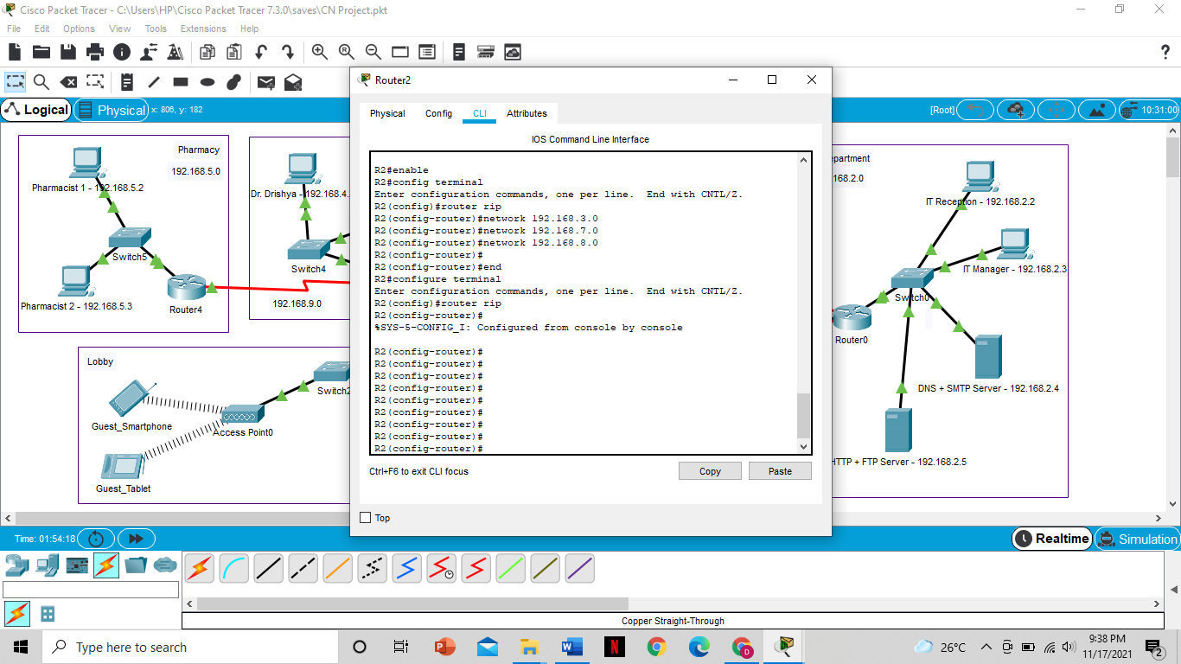

**Configuring HTTP**

HTTP Server is configured with

* IP Address: 192.168.2.5
* Subnet Mask: 255.255.255.0
* Default Gateway: 192.168.2.1
* DNS server: 192.168.2.4

Then HTTP and HTTPS services are turned on and the html pages are edited as per the requirement.

**Configuring DNS**

DNS Server is configured with

* IP Address: 192.168.2.4
* Subnet Mask: 255.255.255.0
* Default Gateway: 192.168.2.1
* DNS server: 192.168.2.4

Then the DNS service is turned on and the name is assigned as dmhospital.com with the address of the HTTP server (192.168.2.5).

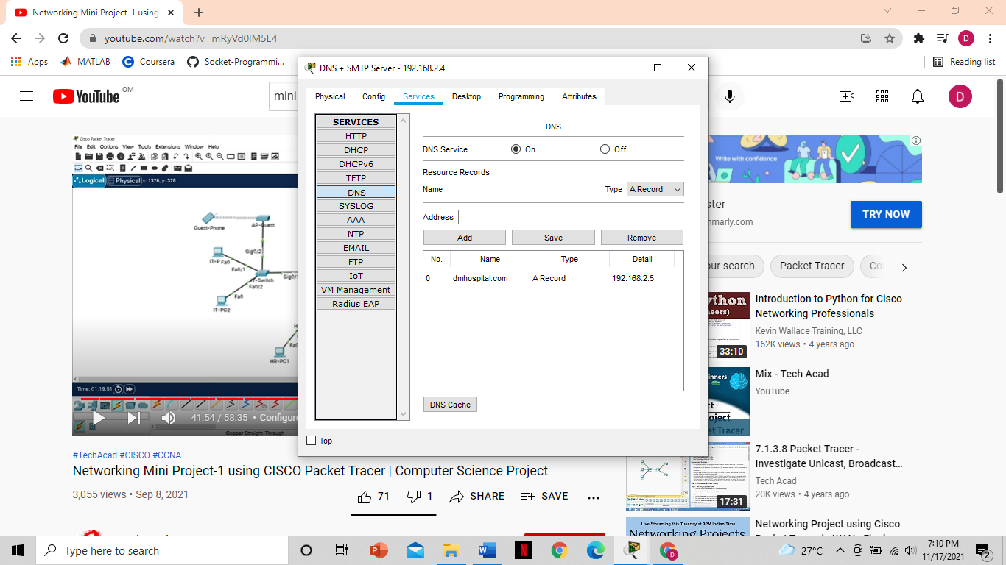

**Configuring DHCP**

DHCP Server is configured with

* IP Address: 192.168.2.5
* Subnet Mask: 255.255.255.0
* Default Gateway: 192.168.2.1
* DNS server: 192.168.2.4

Then the DNS Service is turned on and the values of the fields are set as shown below

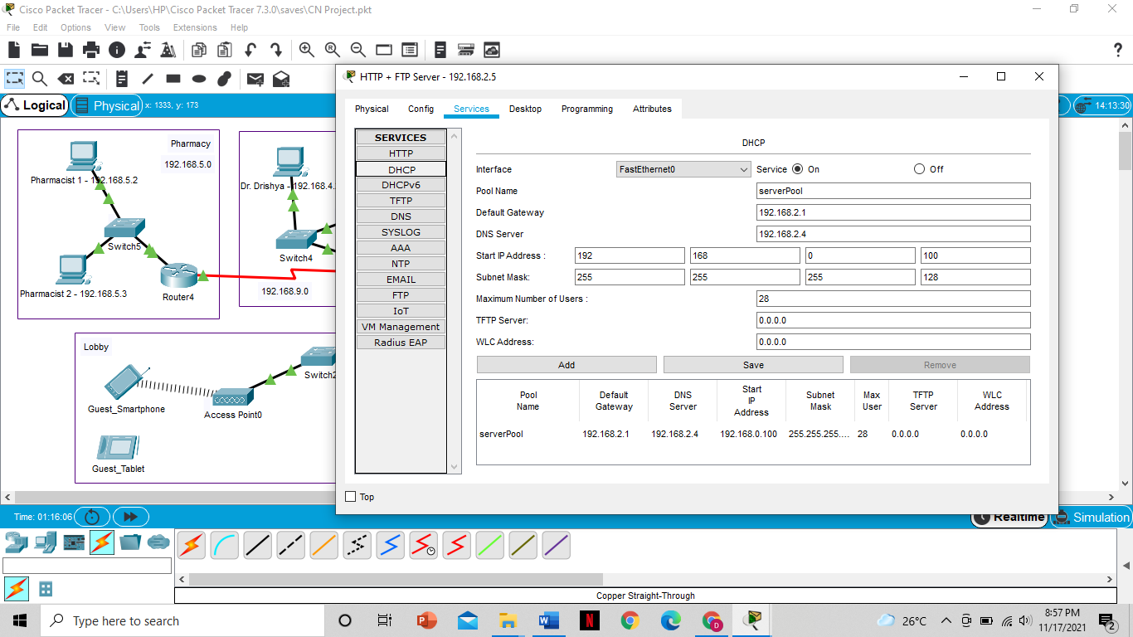

Then these commands are entered in the IT department router

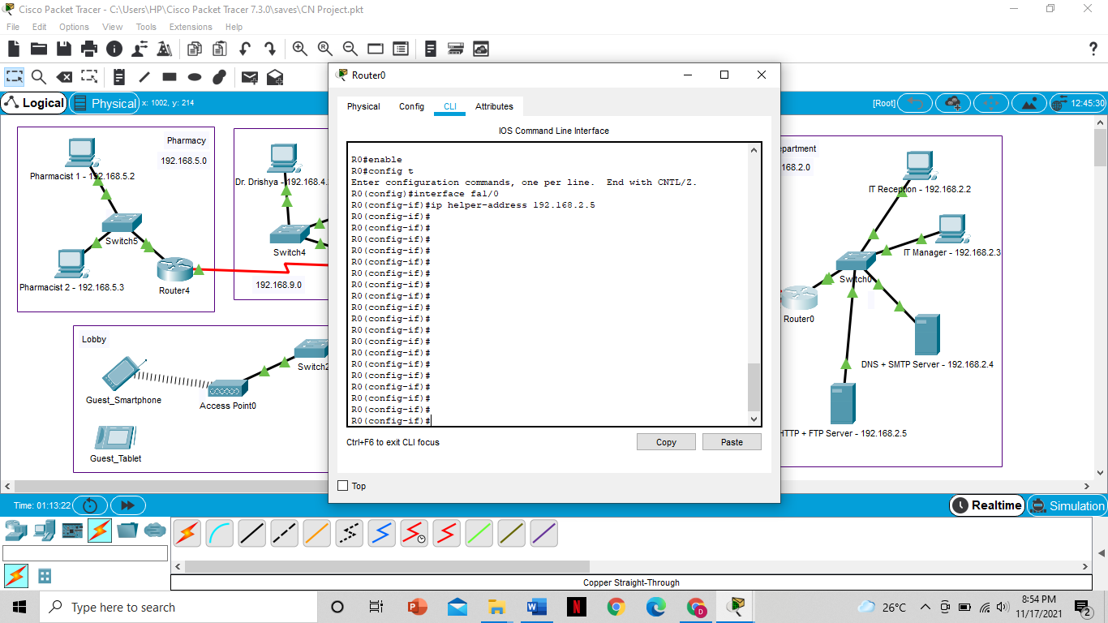

**Configuring TELNET and SSH**:

The following commands are entered in the IT Department router, the Clinical and Test room router and the reception router to configure TELNET and SSH

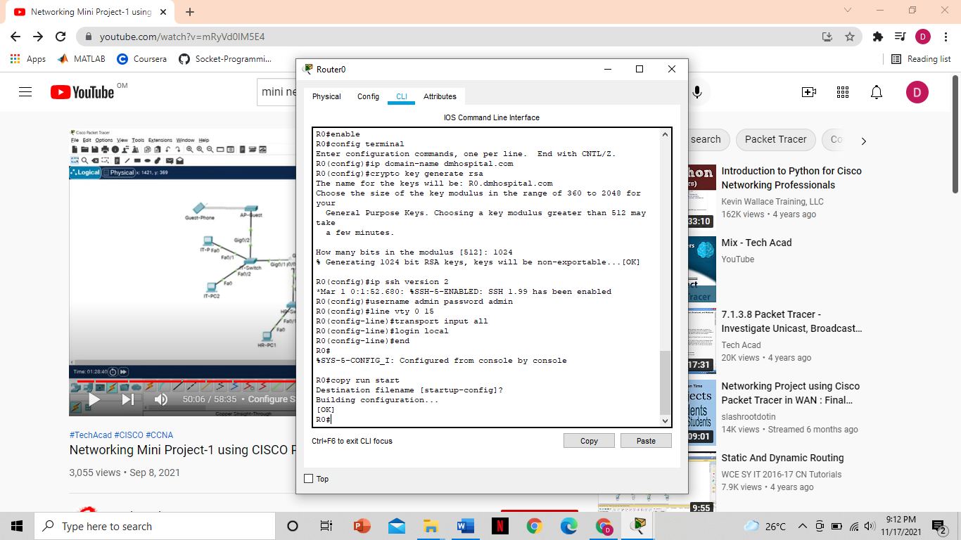

**Configuring FTP**:

* Turn on the FTP service on the FTP server
* Add the required username (here we have used dmhospital) and password (here we have used admin)
* Select the permissions to be given and add.

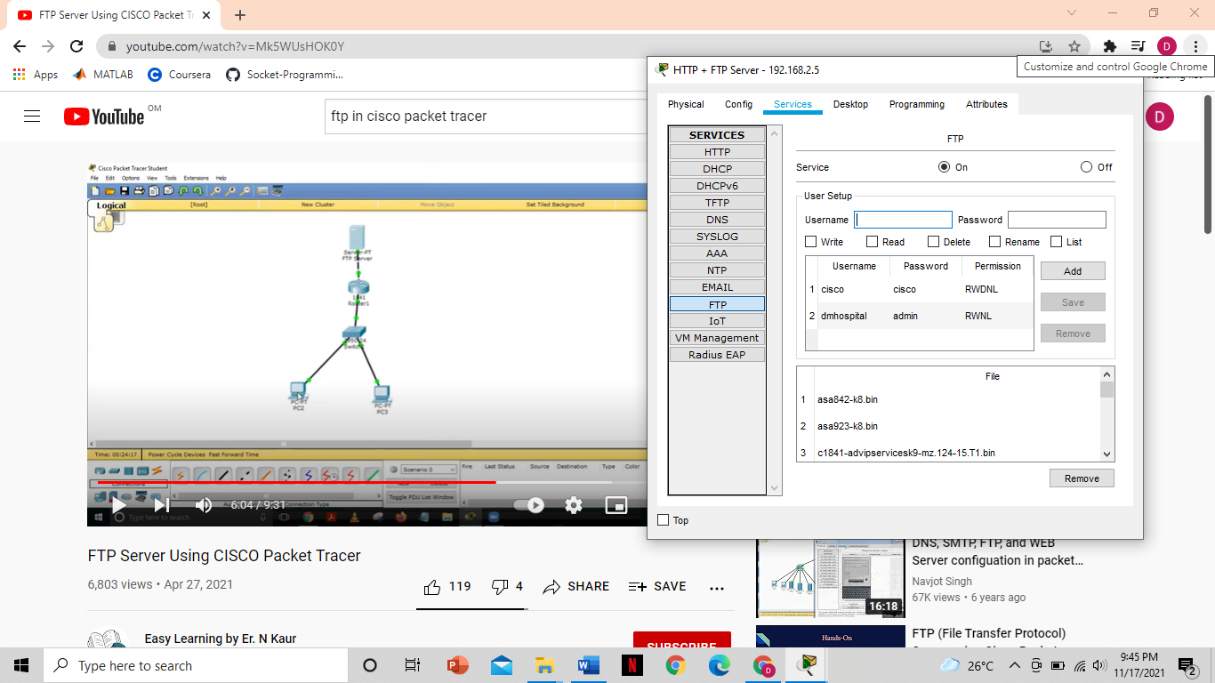

**Configuring SMTP**:

* Turn on the SMTP (Email) service on the SMTP server
* Set a domain name of your choice (here we have used dmhospital.com)
* Add usernames and passwords

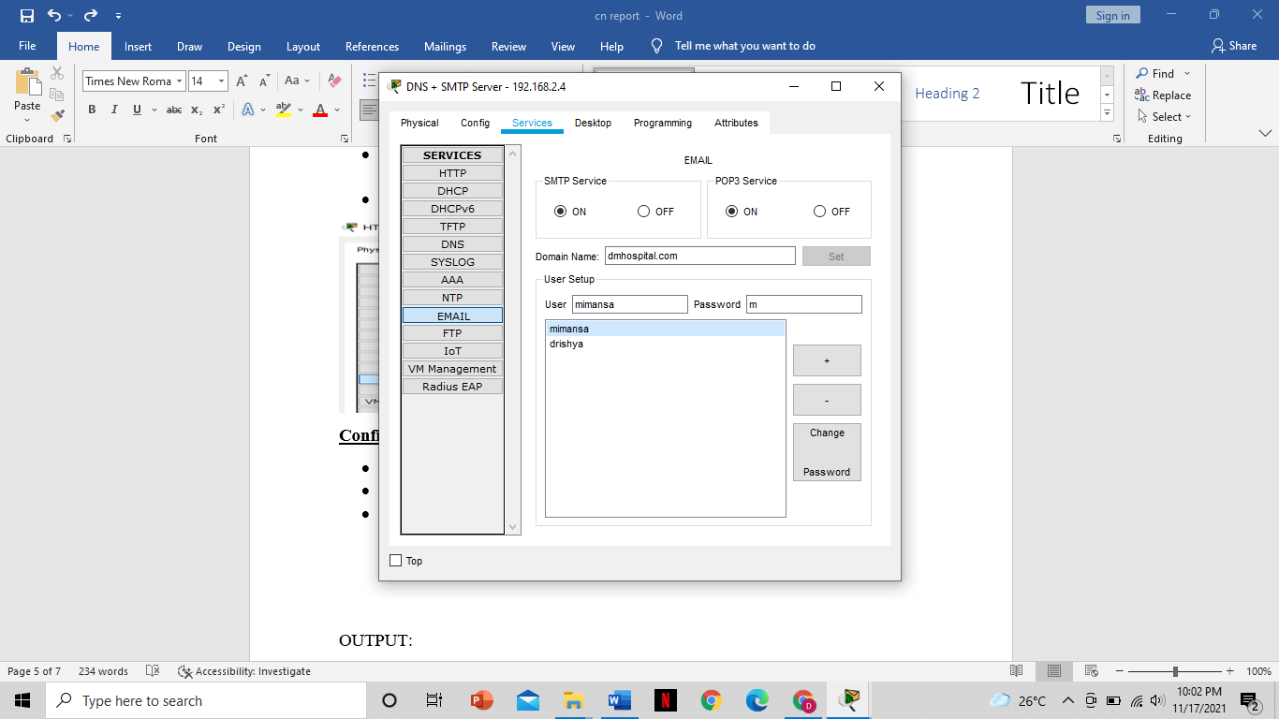

**6. EXPERIMENT RESULTS & ANALYSIS**

**6.1 RESULTS**

**RIP**

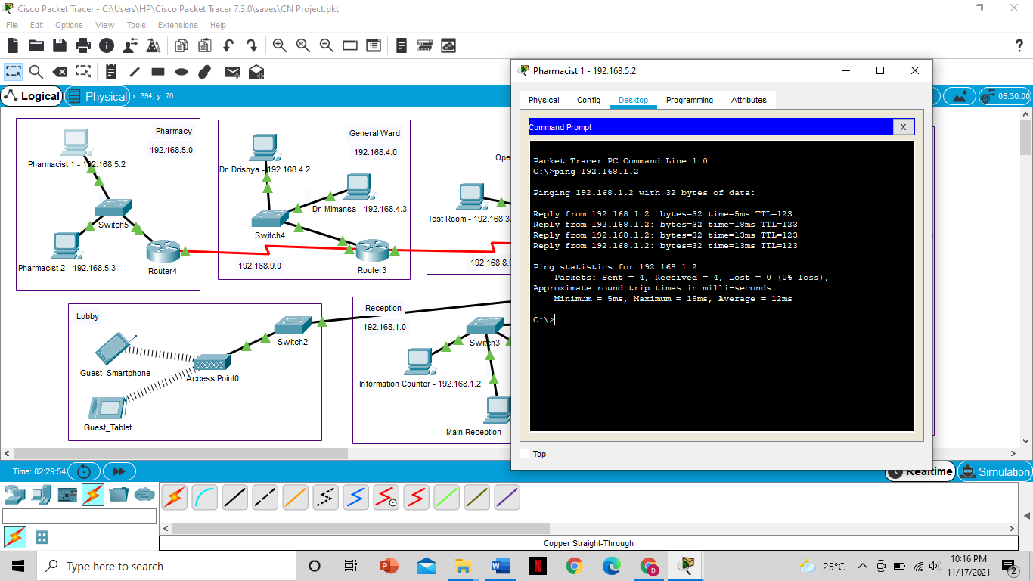

**DHCP**

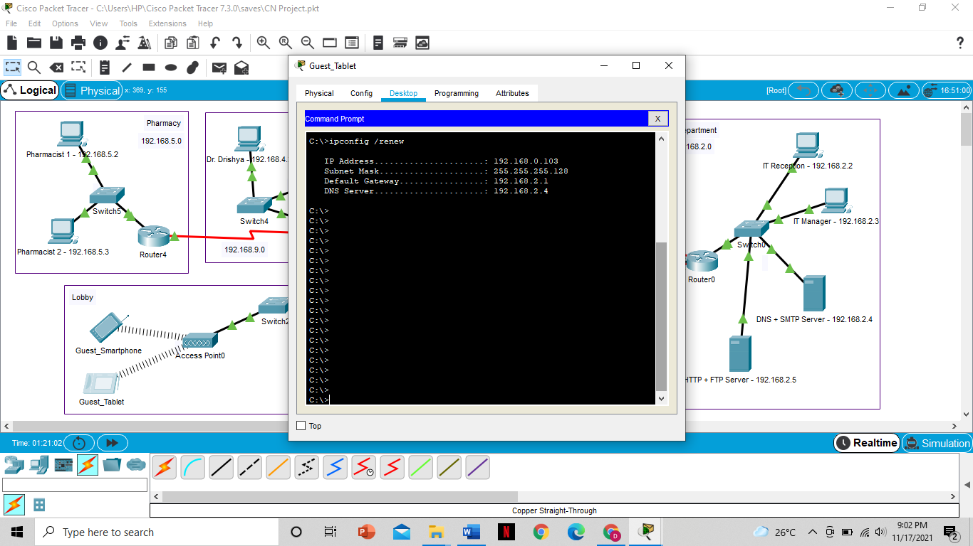

**HTTP** (Verifying using the IP address of HTTP server – 192.168.2.5)

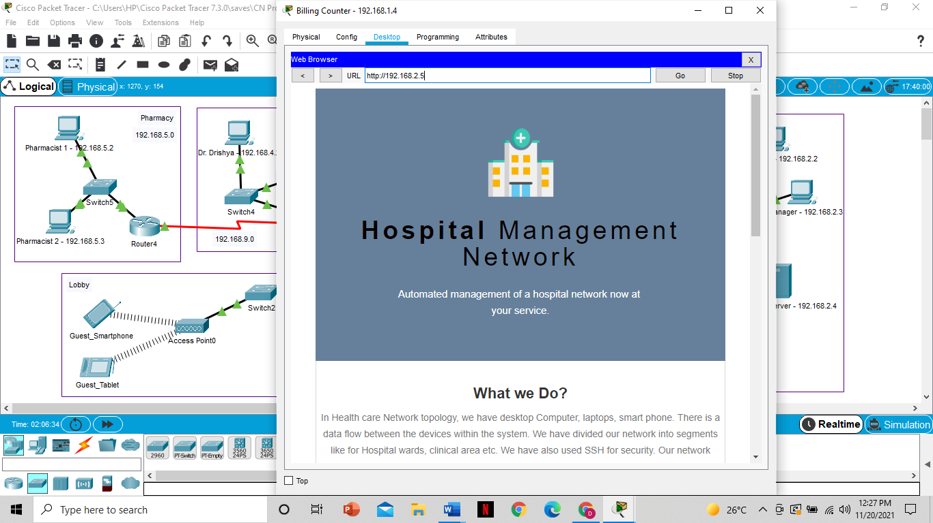

**DNS** (Verifying using the domain name assigned to the HTTP server)

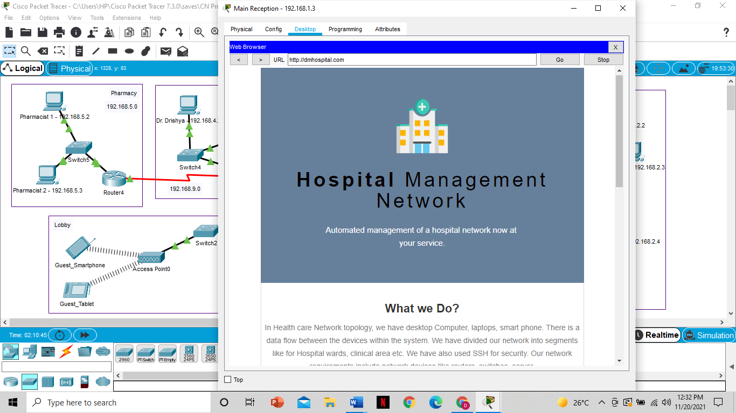

**SSH**

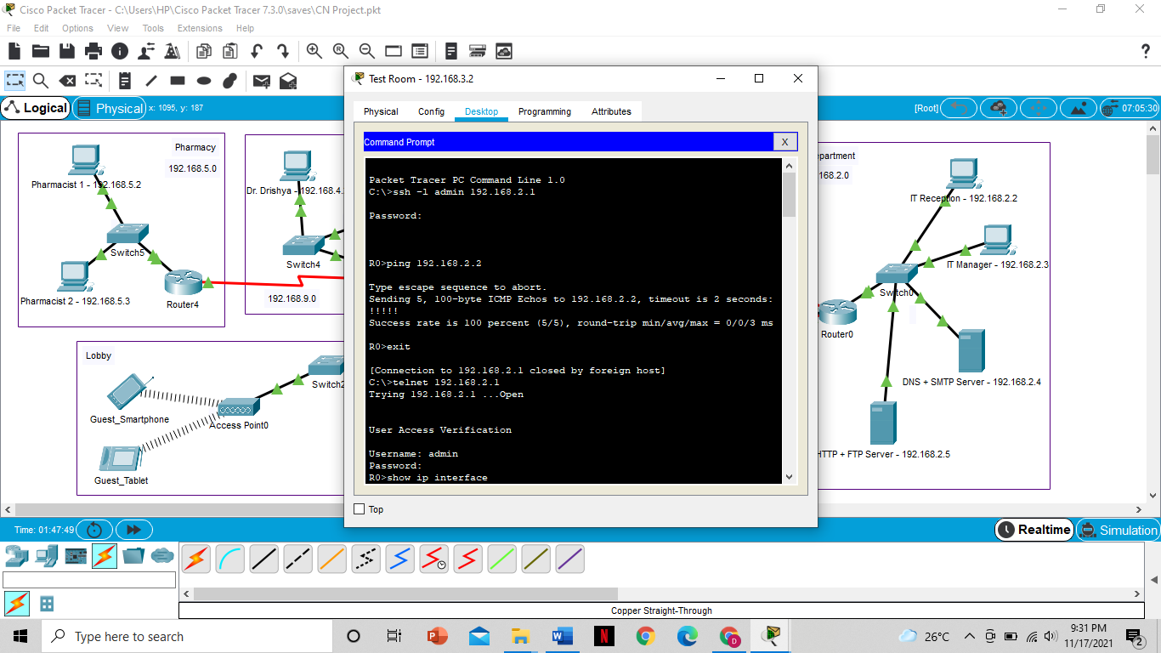

**TELNET**

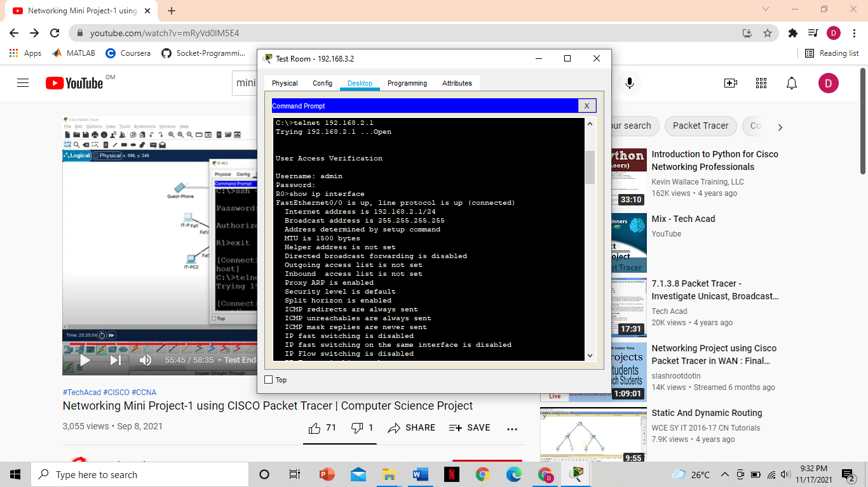

**FTP**

Uploading file from Information Counter

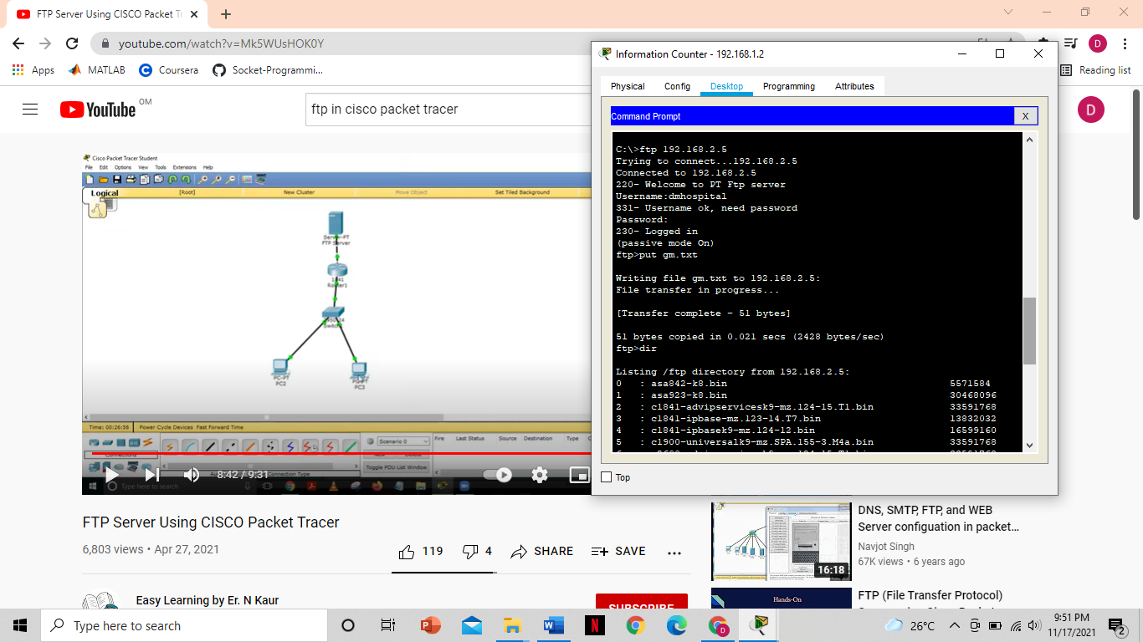

Downloading File on Dr. Drishya’s Computer

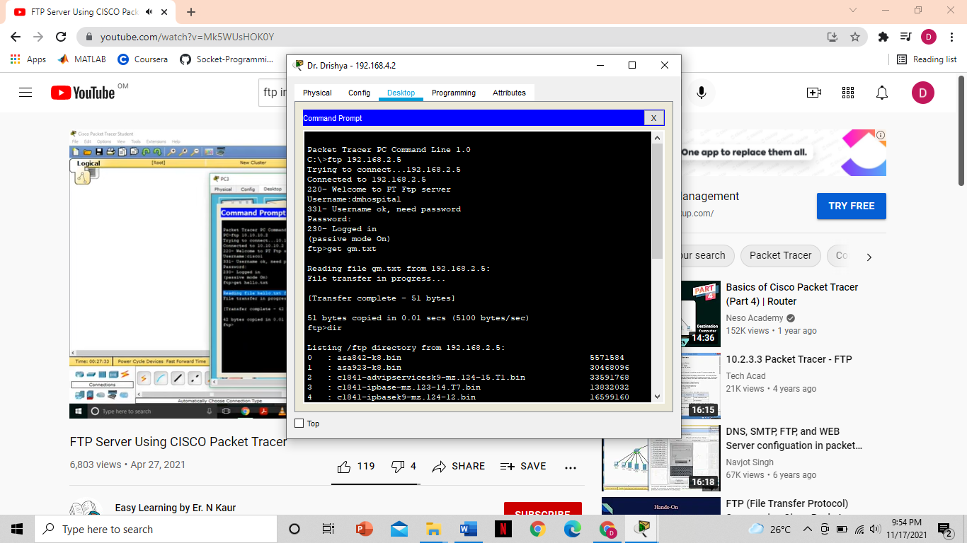

**SMTP**

Configuring and Sending mail from Dr. Mimansa’s Computer

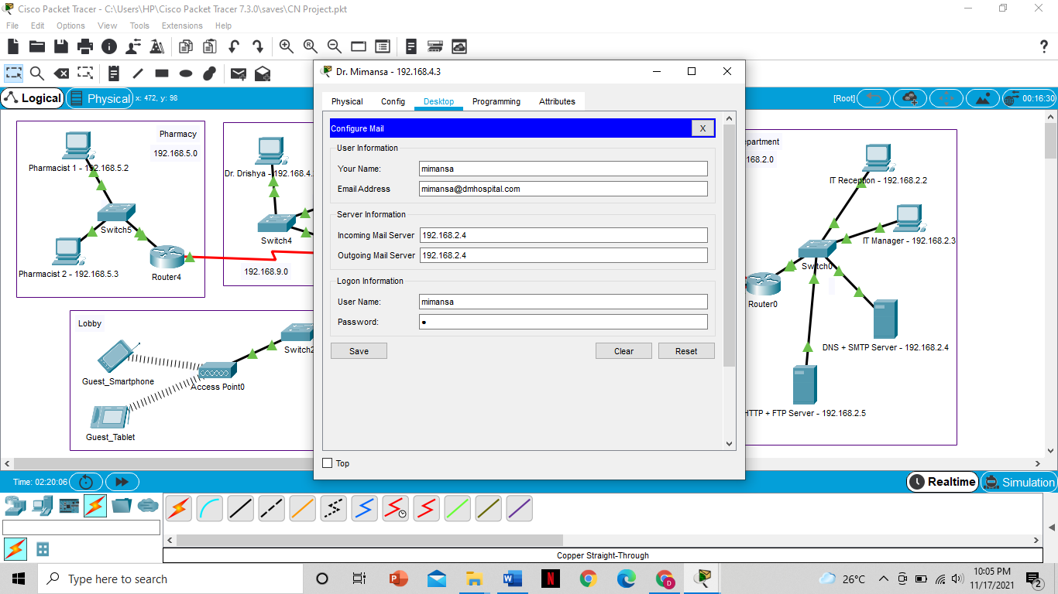

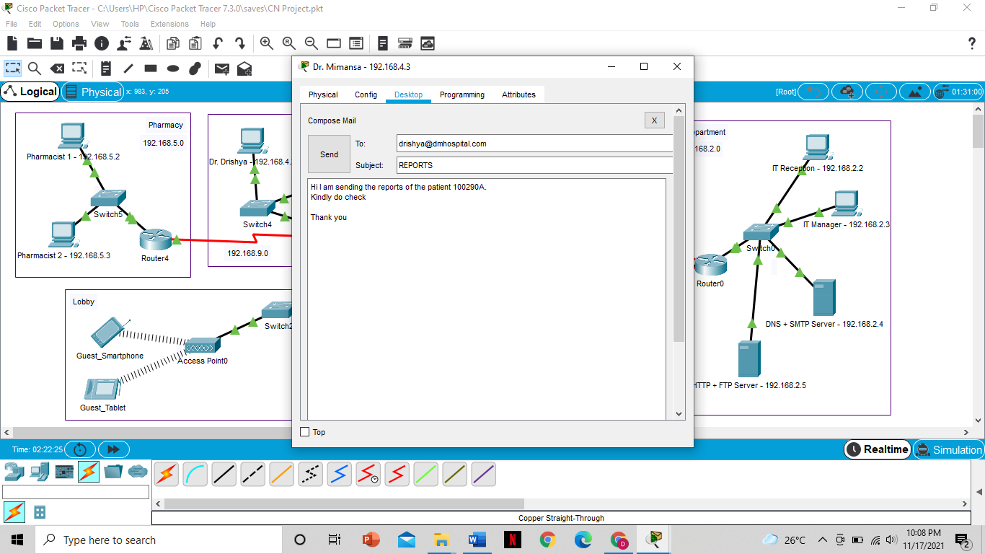

Receiving mail in the Ultrascan room using the Dr. Drishya’s mail ID

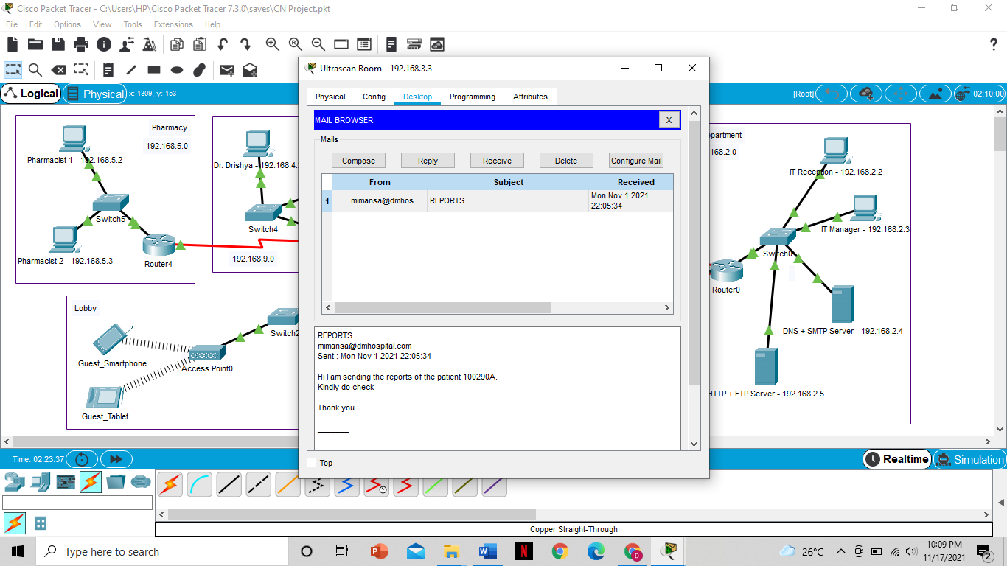

**6.2 RESULT ANALYSIS**

The protocols RIP, FTP, SMTP, HTTP, DNS, DHCP, TELNET and SSH have successfully been implemented.

* RIP enables the efficient communication among different departments
* FTP allows the transfer of different files like patient records and scan reports among different departments.
* SMTP is used to deliver important e-mail messages over the Internet.
* HTTP is used to allow web access and create an official webpage for our hospital. It provides communication between web browsers and web servers
* DNS translates domain names to IP addresses so browsers can load the webpage and eliminate the need for humans to memorize IP addresses
* DHCP is used to automate the process of configuring devices on the IP network, thus allowing them to use network services such as DNS.
* TELNET and SSH are used to remotely access and manage a device. It is used to open a command line on a remote computer

All the protocols have been tested and the required output has been obtained.

**6.3 CONCLUSION & FUTURE WORK**

Hospital Management System is introduced to solve the complications coming from managing and sharing all the paper work of every patient associated with the different departments of hospitalization with confidentiality. Hospital Management System provides the ability to manage all the paperwork in one place, and easily share the paperwork of the patients with the different departments. It helps in maintaining the medical records of the patient and quickly share the details with other departments using the various protocols. It is a time-saving technology which improves the efficiency. It is also cost effective and easily manageable and provides easy access to patient data. This ensures that improved patient care is made possible.

With the growth of Information Technology in every sector and the explosion of medical IOT devices, the design of a network of any hospital has become very essential factor. The hospitals need to have a reliable, secure and scalable network design in order to keep the patient’s information, doctor's research work safe, convenient communication between various departments, etc. as well as keep it ready for any new IOT medical equipment that may be introduced in the future. The hierarchical model of networking best suits our needs along with providing additional features like easy maintenance, high security, simplified troubleshooting and effective performance.

**7. REFERENCES**

The following are few of the reference materials which helped us build this project.

<https://study-ccna.com/>

<https://www.netacad.com/courses/packet-tracer>

<https://www.youtube.com/watch?v=mRyVd0lM5E4>

<https://www.youtube.com/watch?v=Mk5WUsHOK0Y>

<https://computernetworking747640215.wordpress.com/>

<https://en.wikipedia.org/wiki/>